When you see this, can you just text me the program that you guys are using? Cause we would like to possibly edit it if there are stuff to add ! Thanks!

Crop his head and actually put this in the bottom corner (left or right) (as that we can integrate it easier anywhere we want)

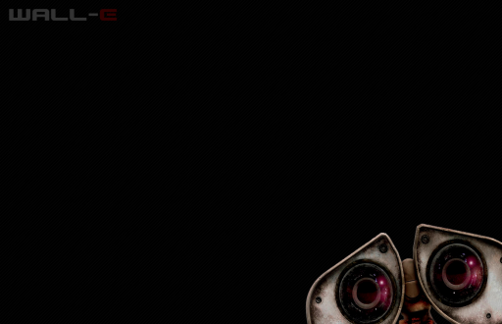

This will look at the robot from the top (or at smth) (only the robot) (as that we can integrate it easier anywhere we want)

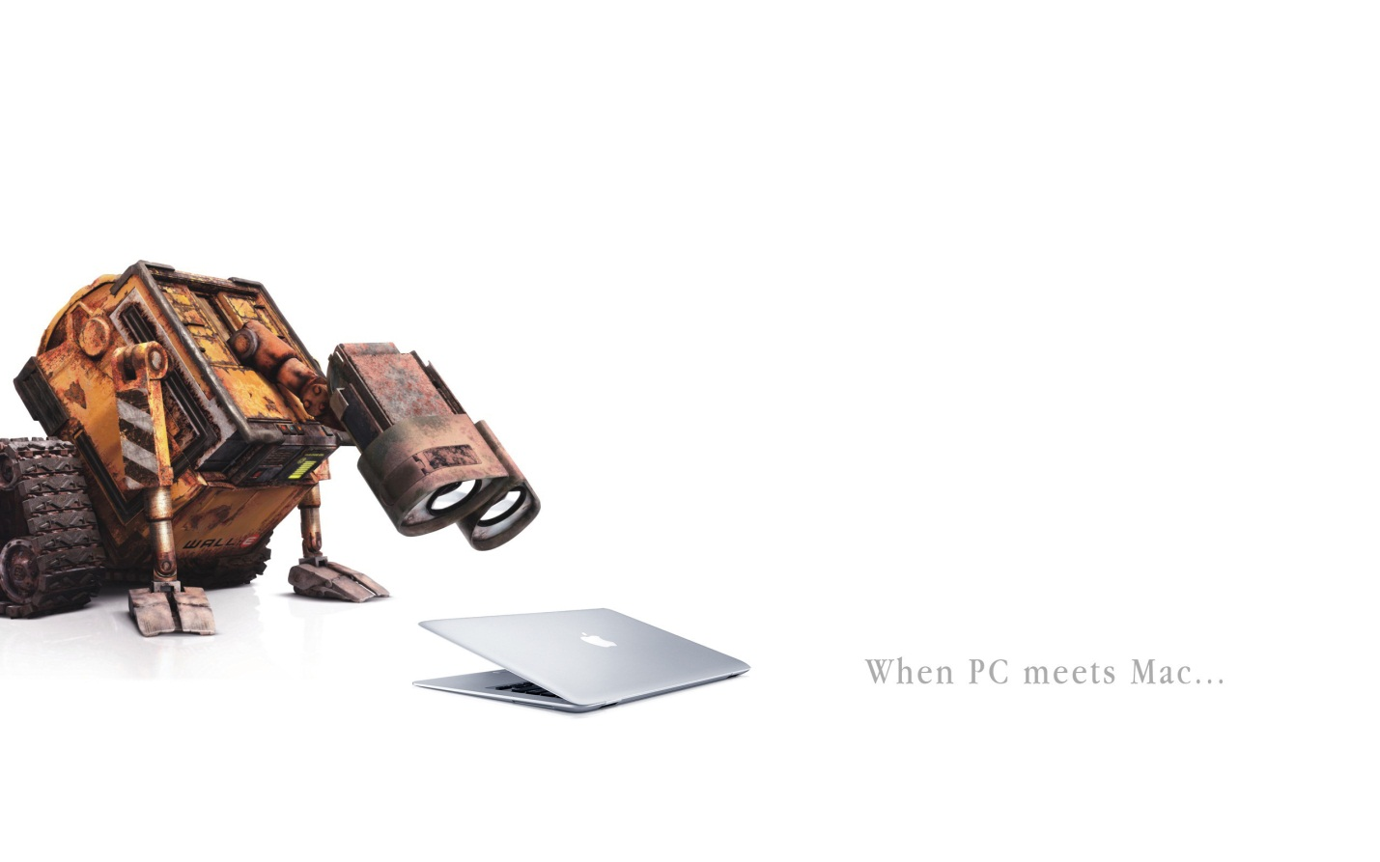

Instead of Head, write ROBOT and crop (isolate the sign) (as that we can integrate it easier anywhere we want)



Make a copy of the obstacle on white

Make a copy of the title on white

Integrate the title and the obstacle in one of those pictures (your choice!)

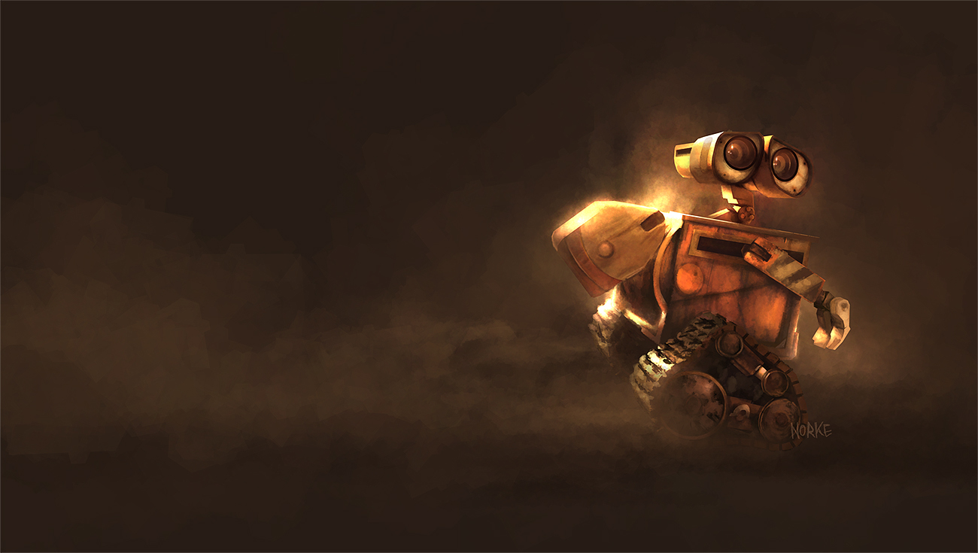



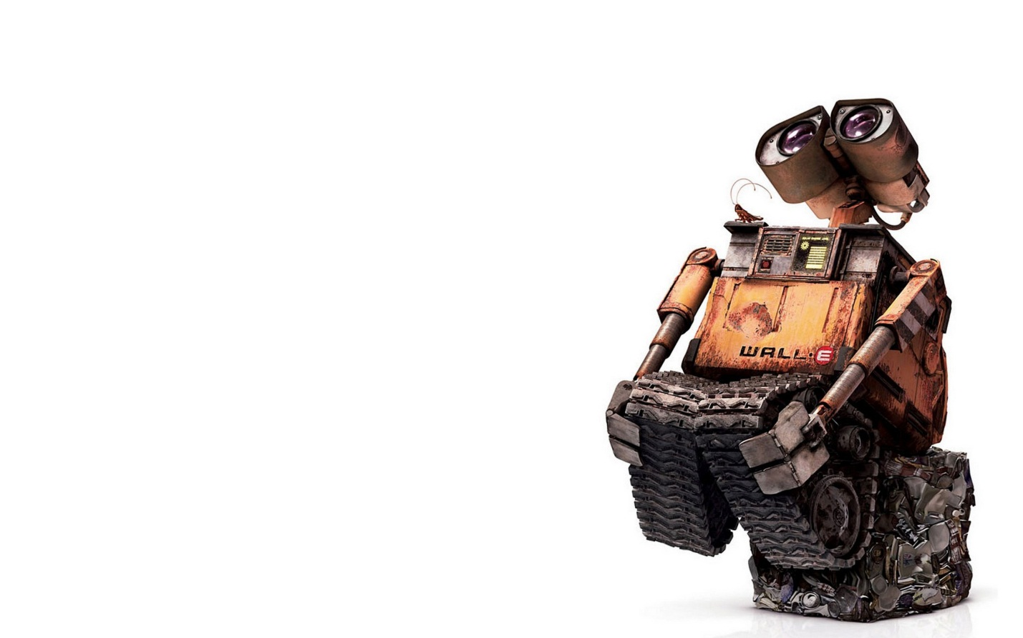

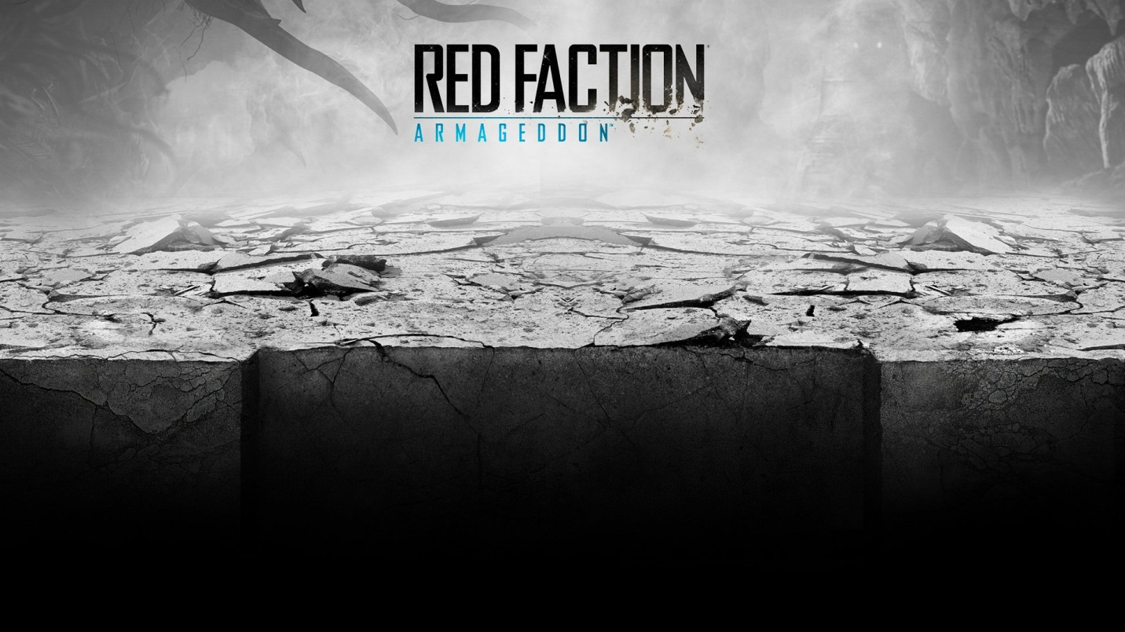

Find a way to incorporate “LET ARMAGEDDON BEGIN” somewhere at the bottom of our design.

Make a layer of the the quote on white (as that we can integrate it easier anywhere we want)

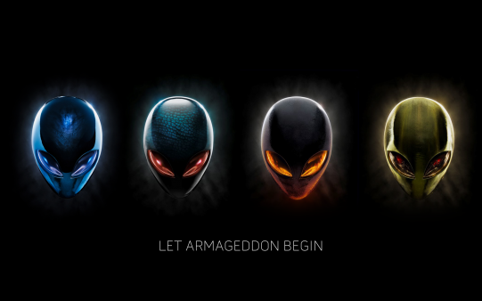

Isolate the next 2 sheep and the pig (so we can move them if we need them)

